1. Changing the tags of the body of text
   1. How do change the format of an object?
      1. 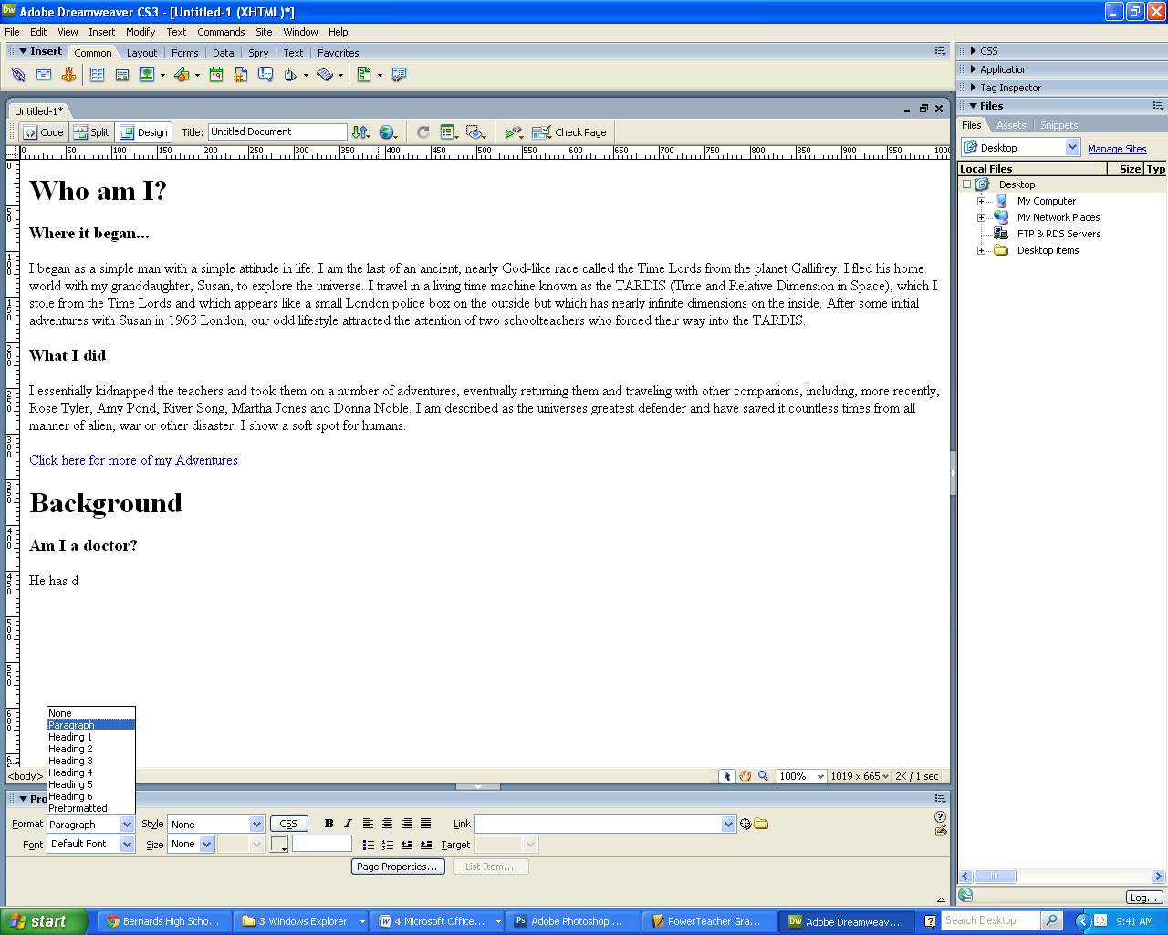The text needs to be____________________________________________
      2. _____________________________________________________________

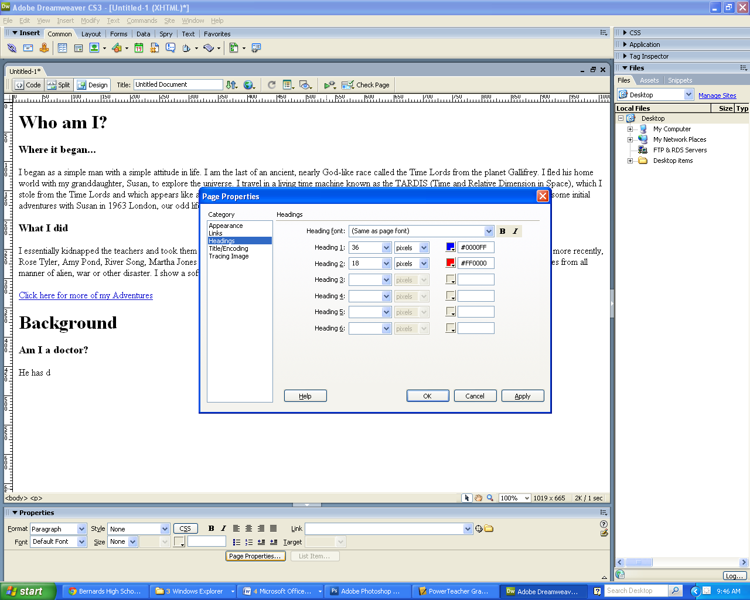

1. Page Properties
   1. Click on the ***heading tab*** in page properties
      1. We can change *__________________*

*____________________________________________________________*

* + 1. Use the information on the right for assignment 2

1. Creating a link in DW
   1. _____________________________________ you want to create the link.
      1. Under the link dropdown, __________________________________________.
      2. 